02.30 OVERALL ANALYTICAL REVIEW

The following describes the functionality and features included in Probe Audit Premium+

Objective

The objective of this document is to present key financial metrics and ratios for the engagement team to perform an overall analytical review of the entity's financial performance and position at the conclusion of the audit.

The following key concepts of the Probe Audit Premium+ Methodology are set in this document:
- Final analytical procedures to form an overall conclusion on the financial statements (ISA 520)
- Identification of previously unrecognised risks of material misstatement, including fraud
- Consistency of financial statement trends with the auditor’s understanding of the entity

Document placement

Document 02.30 – Overall analytical review can be found in the Finalisation folder in the Caseware document manager.
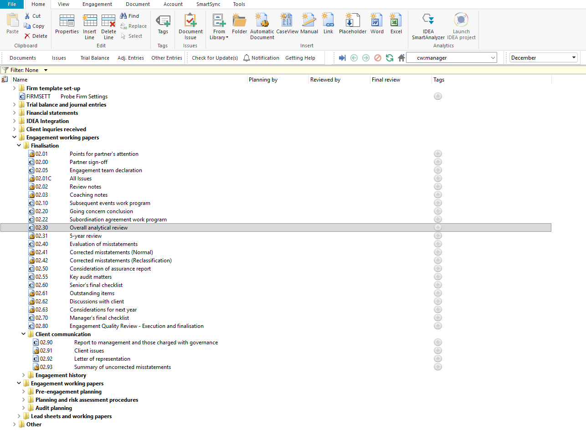

Document content

This document is designed to be a summary document that presents pre-populated financial metrics and ratios for analytical review. The financial metrics are automatically calculated from the engagement file data and include income statement items, balance sheet items, and financial ratios. Each metric displays the current year value, prior year comparative value, and the percentage change between the two periods.

The document addresses the requirements of ISA 520 – Analytical Procedures for performing overall analytical procedures at or near the end of the audit. The document presents all financial metrics in a single continuous view.
[Screenshot: Document map showing bookmarks]

Layout
Column | Input Required | Outcome
Sign-off
Planning by | Enter the name or initials of the engagement team member responsible for planning the overall analytical review. | No impact on the engagement file. Records who performed the planning-stage review of the overall analytical review.
Reviewed by | Enter the name or initials of the engagement team member who reviewed the overall analytical review. | No impact on the engagement file. Records who reviewed the overall analytical review.
Performed by | Enter the name or initials of the engagement team member who performed the overall analytical review. | No impact on the engagement file. Records who performed the overall analytical review.
Final review | Enter the name or initials of the engagement team member who performed the final review of the overall analytical review. | No impact on the engagement file. Records who performed the final review of the overall analytical review.
Financial metrics
Financial metric | No input is required in this column. Displays pre-populated financial metric labels including income statement items such as Revenue, Gross profit, Cost of sales, Net profit before tax, and Net profit margin, balance sheet items such as Current assets, Total assets, Current liabilities, Total liabilities, and Equity, and financial ratios such as Return on assets, Return on equity, Asset turnover, Current ratio, and Debt / equity ratio. | No impact on the engagement file. Identifies each financial metric presented in the overall analytical review for the engagement team to assess.
Current year | No input is required in this column. Displays the current year value for each financial metric, automatically calculated from the engagement file data. | No impact on the engagement file. Presents the current period amount or ratio for review by the engagement team.
Prior year | No input is required in this column. Displays the prior year comparative value for each financial metric, automatically calculated from the engagement file data. | No impact on the engagement file. Presents the comparative period amount or ratio for review by the engagement team.
% Change | No input is required in this column. Displays the percentage change between the current year and prior year values, automatically calculated. | No impact on the engagement file. Highlights the year-on-year movement for each financial metric to assist the engagement team in identifying significant fluctuations requiring further investigation.

Document outcomes

The engagement team must complete the sign-off fields to record who planned, performed, reviewed, and finalised the overall analytical review.

The engagement team must review the pre-populated financial metrics to assess the entity's financial performance and position. The metrics include income statement items such as revenue, gross profit, cost of sales, other income, overheads, net profit before and after tax, and net profit margin, balance sheet items such as current assets, non-current assets, total assets, current liabilities, non-current liabilities, total liabilities, and equity, and financial ratios such as return on assets, return on equity, asset turnover, current ratio, and debt to equity ratio. The engagement team must consider whether the percentage changes between the current and prior year are consistent with their understanding of the entity and identify any significant or unusual fluctuations that may require further investigation.

Group Audits

When the engagement type was selected as 'Group Audit Single' or 'Group Audit Multiple', the overall analytical review applies to the group engagement. The engagement team must evaluate the financial metrics at both the group and component level and consider the impact of component performance on the group's overall financial position.

IN CONCLUSION

Features

The following features are available in the document:

Insert or delete a comment, see page F3

Guidance, see page F16

Freeze, see page F19

